Final Project: Natural Language Processing with Disaster Tweets

Competition Details
The project I intend to complete is a Kaggle Competition called Natural Language Processing with Disaster Tweets. I chose this project because I have a personal interest in “fake news” and how it is spread through social media. This kind of project could help people more easily separate facts from memes and propaganda.
This competition seeks to train a Large Language Model (LLM) to predict whether any given tweet is reporting a real disaster or not. Twitter is often used as a communication channel during emergencies. Disaster reports and updates are made in real time by real people. Disaster relief and emergency response organizations are looking to comb through tweets to help respond to events even faster. The problem lies within the nuance and complexity of human internet speech. People online (otherwise referred to as netizens) tend to use hyperbolic speech, quickly evolving slang, metaphors, and sometimes outright falsehoods to refer to any given situation. While these posts can generally convey their true meaning to a human audience, LLM’s struggle.
This competition intends to increase the accuracy of LLM when used to predict the occurrence of a disaster through twitter. Submissions are evaluated by using the f1 score between predicted and expected answers. This competition requires models that results in a binary classification. Each tweet will be tested and rated as either a 1 (a real disaster report) or 0 (not a real disaster). The competition’s URL is linked here: Natural Language Processing with Disaster Tweets . There is no submission date for this competition as it will run indefinitely.

Visualizing Data
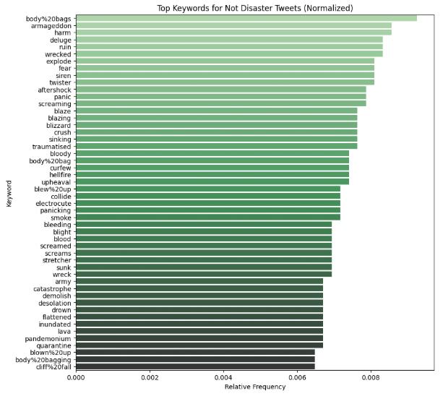
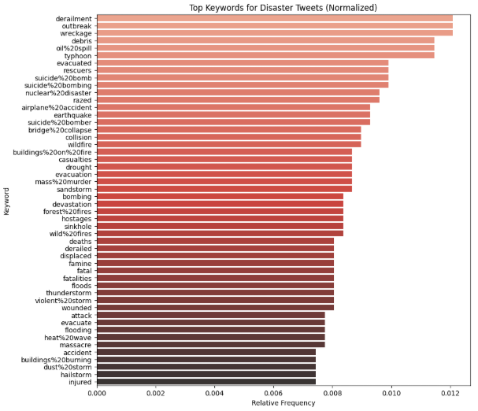
Initially I observed the data given in train.csv and test.csv. I found that the training dataset was divided into 5 headers: ‘id’, ‘keyword’, ‘location’, ‘text’, and ‘target’. The summary() function revealed that the location and keyword columns were often left blank or NAN. The location field was most likely to have outliers such as ‘MAD as Hell’. I then plotted several graphs like frequency bar charts and Venn diagrams to understand the distribution of terms used in tweets better.
Figure 1 *See Visualizations.ipynb*
By splitting the trainDF dataframe by target (0 : Not Disaster and 1: Disaster respectively) then implementing a counter on each I was able to gather several other datasets based on ‘keywords’ and ‘text’. I started by graphing the frequency of the first 50 ‘Keywords’ for each target designation. This revealed an interesting phenomenon where none of the first 50 terms for either designation experienced any overlap. I then increased the threshold to top 100 keywords and found only 3 that overlap(See Figure 2).
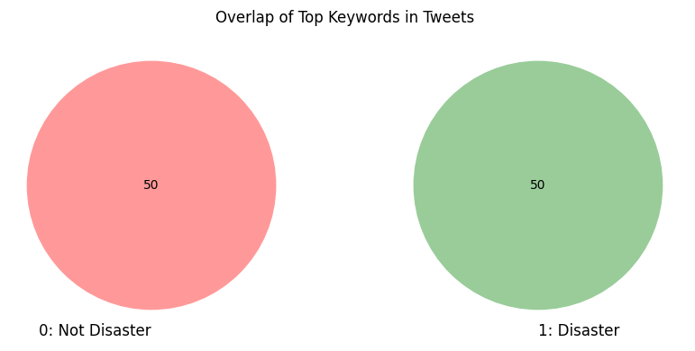
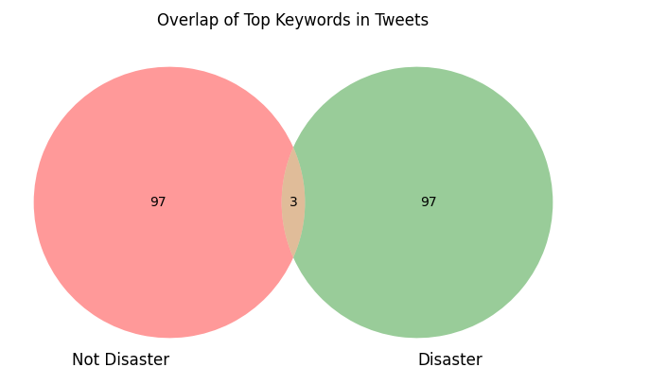
Figure 2 *See Visualizations.ipynb*

Though there is a lower overlap than I expected, even the most used words in the data fail to break 1% of the total data. This means they can’t be expected to matter much to the model. Nevertheless, I continued the same steps with Vocabulary and hashtags in case I found a way to incorporate this data later in the competition. The data used was only transformed to lowercase. Please, see the Visualizations file for more information.

Initial Approach
I set out to test out 4 base models; Linear Regression, Random Forest, Support Vector Machine, and a Neural Network. The model that yielded the highest F1-score on the testing/validation split (not the submission score) was then tweaked. The data was cleaned of extra spaces, special characters, numbers, urls, html languages, and stopwords before models were used.
Initial Scores:
- Linear Regression F1-Score: 0.5938
- Random Forrest F1-Score: 0.3706
- Support Vector Machine F1-Score: 0.7148
- Neural Network F1-Score 0.7257

Neural Network
The Neural Network (NN) had the highest initial F1-score. Quickly after starting this model’s tuning, I ran into a problem. The F1-Score was not increasing in a positive manner (stalling at about 0.74). Additionally, Collab’s CPU severely limited the computational power of this model. Soon the time the model was taking to train was in the hours and would only result in an overfitting of the training data. I tried several different methods including using the data gained from the above venn diagram’s to complete a special feature that added to the model’s training, this still only increased the F1-Score minimally.
I then pivoted to use a Bidirectional Encoder Representation from Transformers (or BERT) model. I was having more success in tuning this model but unfortunately received too many errors related to the Keras package to continue. In the future I would like to look more into this model, but the time would not allow. Since the BERT model was not running successfully I pivoted yet again to an unlikely model Linear Regression.

Linear Regression
I researched ways to mimic a Keras Bert model using Copilot and found that Linear Regression can mimic its approach. This is done by using a SklearnWrapper (see SKLearnLRF.ipynb) to create a TF-IDF + Logistic Regression model. It is used in a similar way to a BERT model. I made use of GridSearchCV to test different hyperparameter settings for the best performance. This specifically tunes C(regularization strength) and penalty(L1 vs. L2) values. The pipeline uses a TfidfVectorizor which tokenizes words into numbers based on frequency and the ngram_range(1,3)within allows it to recognize phrases up to 3 words long. The fit then trains the pipeline on the training data and using the other methods mentioned above saves the best model produced for future use.

Other Notable Changes to Increase F1-Score
- Increasing the ngram_range(1,2) to ngram_range(1,3).
- Increasing the max_features =1000000.
- Increasing the max_iter=10000.
- Introducing class_weight=”balanced”.
- Changing the solver=’saga’ from ibfgs.
- Creating a parameter grid.
- Batch_size = 8.
- Implemented early_stopping if loss became too great.
- Implemented special features derived from keyword, hashtag, and text frequencies.

Future Research
If I were to do this project again, I would like to do more research on the different types of Neural Networks and stopwords. From my initial research into this subject, I learned that a correctly trained NN can do amazing things with Natural Language Processing. Unfortunately, the limitations of computing power and time didn’t allow me to test other models like BERT. Additionally, during the visualization stage of the project, I found that stopwords occur more often in non-disaster tweets than in disaster tweets. I didn’t have time to figure out a good way to implement that into my special features function. However, I found that there is a significant difference in accuracy and F1-Score when using and not using stopwords. I would investigate more statistics around word choice and situational severity.

Conclusion
Though the Linear Regression model was not promising at first, implementing a TF-IDF helped elevate this model’s capabilities. F1-Score from 0.5938 to 0.7257 (when running on the validation set). Upon submission to Kaggle this model final yielded an F1-Score of 0.79773. My highest position on this competition leaderboard is about 436.

